

# M.V.P.SAMAJ’S



K.R.T ARTS, A.M.SCIENCE AND B.H.COMMERCE

COLLEGE, GANGAPUR ROAD NASHIK.

**A PROJECT REPORT**

**ON**

**PATHOLOGY LAB SYSTEM MANAGEMENT**

**Developed by**

Bhagyashri Samadhan Nikam

Mitali Ramrao Lanjewar

B.C.A. (Science) (2023-2024)

Under the guidance of

Prof. D.R.Derle



ACKNOWLEDGEMENT

We are happy to present the project *“*Pathology Lab System Management*”* in JAVA.

A Project titled *“***Pathology Lab System Management** ” would not have been completed without the valuable guidance and encouragement of “D.R.Derle ” and all staff members. We acknowledge them for their moral support.

This project is substantially upgrading our skill of software development which we intend to good use in developing better system in future.

In conclusion, we would like to express our thanks to management for providing us all facilities for completion of our project.

Finally we extend our thanks our all B.C.A (Science) staff, Classmates and also thanks to our parents to help us all time.

And special thanks to my Friends who helped us for successful completion of this project. They pointed out errors &suggested changes, thus helped in many ways, give us the idea of this project.

## Bhagyashri Samadhan Nikam.

## Mitali Ramrao Lanjewar.



INDEX

|  |  |  |
| --- | --- | --- |
| **Sr.No** | **Title** | **Page NO.** |
| **1.** | Introduction | 1 |
| **2.** | Problem Definition. | 2 |
| **3.** | Need of System | 3 |
| **4.** | Scope of System | 4 |
| **5.** | Feasibility study. | 5 |
| **6.** | H/w and s/w requirement | 6 |
| **7.** | ERD | 7 |
| **8.** | DFD | 8-10 |
| **9.** | Data Dictionary. | 11-13 |
| **10.** | Sample I/O Screen. | 14-22 |
| **11.** | Conclusion | 23 |
| **12.** | Limitations | 24 |
| **13.** | Bibliography | 25 |



INTRODUCTION

This application focuses on addressing day-to-day operational needs of pathology lab. It can be used for maintaining patient details and their test result. It helps in maintaining records of different tests, payment dues and also analyses test results.

Provide interfaces to integrate with electronic health records (EHR) and other healthcare systems for seamless data sharing.

The Pathology Lab Management System project aims to streamline and enhance the efficiency of pathology laboratories. This system will automate the processes involved in sample tracking, result generation, and overall lab management. By integrating technology, it seeks to reduce manual errors, improve turnaround times, and provide a user-friendly interface for lab personnel. This project addresses the need for a comprehensive solution in pathology labs, ensuring accurate data management and facilitating better patient care.

1

# PROBLEM DEFINATION

The pathology lab system management problem involves designing and implementing a comprehensive solution for efficiently managing various aspects of a pathology laboratory.

This includes sample tracking, test management, result reporting, inventory control, personnel scheduling, and compliance with regulatory standards.

The goal is to streamline operations, enhance accuracy, and ensure timely delivery of reliable pathology services.

The new system is to control the following information:

Patient information, room availability, staff operating and patient invoices.

2

# NEED OF SYSTEM

The computerized system was needed because there were following drawbacks in the present manual system.

* Manual data entry and processing increase the risk of human errors, leading to inaccurate test results, mislabeling of samples, or data inconsistencies.
* Manual handling of paperwork, sample tracking, and result generation is time-consuming, potentially leading to delays in providing test results to patients
* Difficulty in tracking the entire lifecycle of samples manually can result in a lack of traceability, making it challenging to identify errors or locate specific samples.
* Manual sample tracking may lead to inefficiencies in managing the storage, retrieval, and disposal of samples, increasing the risk of sample mix-ups.
* Manual processes often result in higher operational costs due to the need for extensive paperwork, increased manpower, and the potential for errors that may require costly corrections

3

# SCOPE OF SYSTEM

Implement a billing module to generate accurate invoices for tests

conducted, capturing essential details for insurance claims .

Integrate a comprehensive reporting module that allows for the

generation of detailed and customizable reports for patients and

healthcare providers.

Create a centralized and secure database for managing patient

information, including demographics, medical history, and previous test results.

Implement a robust system for automated sample tracking from

collection to analysis, ensuring accurate and efficient sample management

The proposed Pathology Lab Management System aims to overcome the

limitations of manual processes by leveraging automation and technology.

4

FEASIBILITY STUDY

An important outcome of preliminary investigation is the determination that the requested system is feasible for organization or not.

There are three aspects of Feasibility Study are as follows:

### Operational Feasibility: -

The operational feasibility of a pathology lab system management involves assessing whether the proposed system can be effectively implemented and integrated into the existing workflow. It includes evaluating factors like staff readiness, training requirements, potential disruptions, and overall compatibility with current processes. Conducting a thorough analysis of these aspects helps determine if the implementation is practical and aligns with the lab's operational needs.

### Technical Feasibility: -

A pathology lab system is technically feasible with the right software solutions. Implementing a Laboratory Information Management System (LIMS) can streamline sample tracking, results management, and overall lab operations. Integration with analytical instruments, data security measures, and user-friendly interfaces are essential components for successful implementation**.**

.

### Economical Feasibility: -

An Economical feasibility study for a pathology lab system management involves analyzing costs, benefits, and potential returns on investment. Consider factors like software/hardware expenses, maintenance, staff training, and expected efficiency gains. Assess if the long-term benefits outweigh initial costs, factoring in increased productivity, improved accuracy, and potential revenue growth.

Engage stakeholders to gather insights and ensure the system aligns with the lab's goals.

5

# HARDWARE SOFTWARE REQUIRMENTS

### Hardware Requirements:

* + i3 Processor
  + 8 GB RAM
  + 500 GB HARDDISK

### Software Requirements:

* OPERATING SYSTEM:Windows
* LANGUAGE:HTML5, CSS3, JSP
* BACKEND: Postgresql

6

ER-DIAGRAM

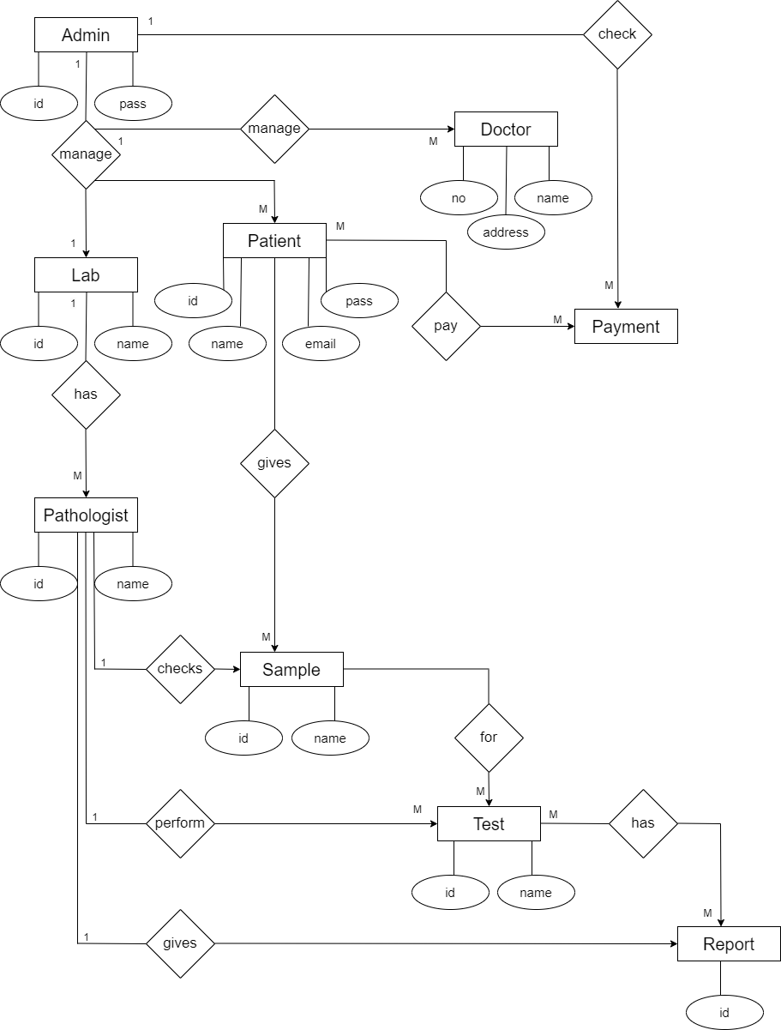

7

DFD-DAIGRAMS

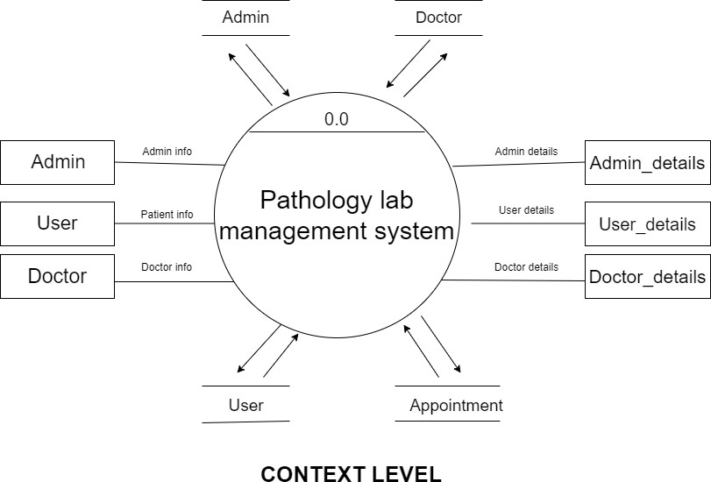

8

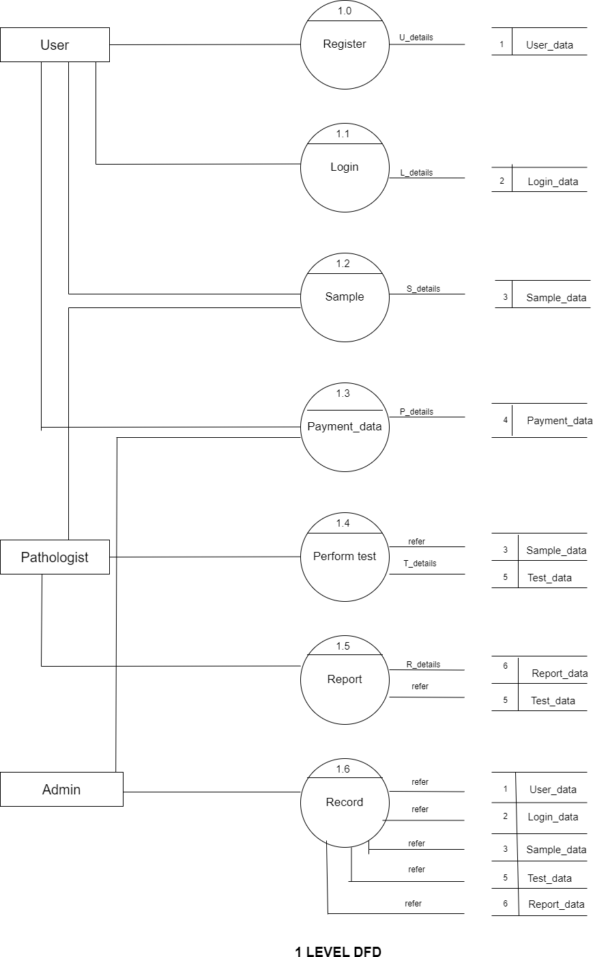

9

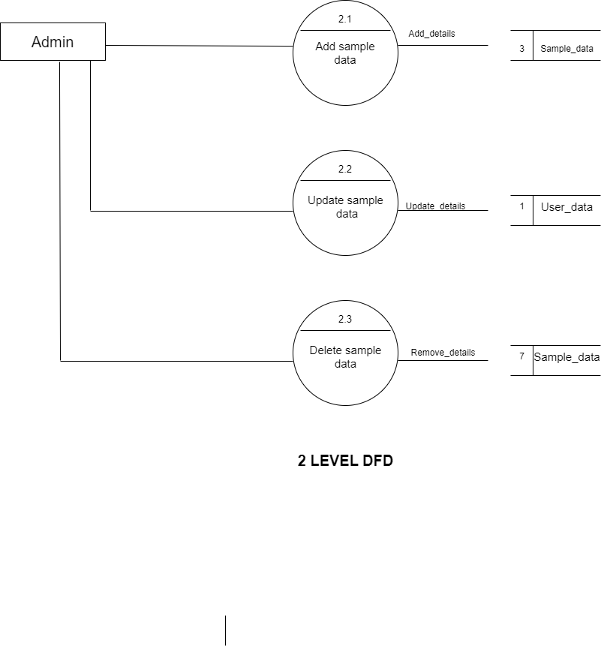

10

Data Dictionary

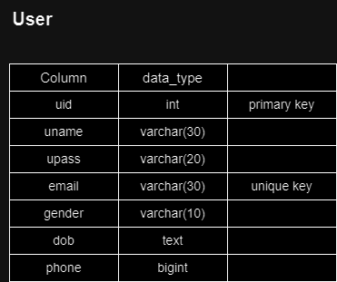

11

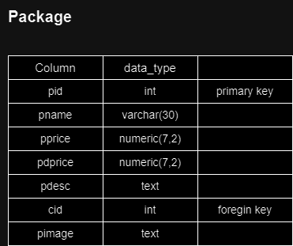

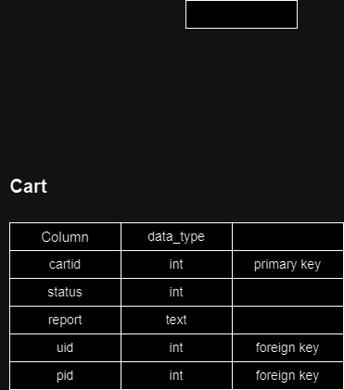

12

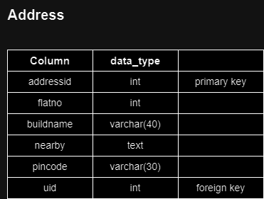

13

INPUT OUTPUT SCREENS

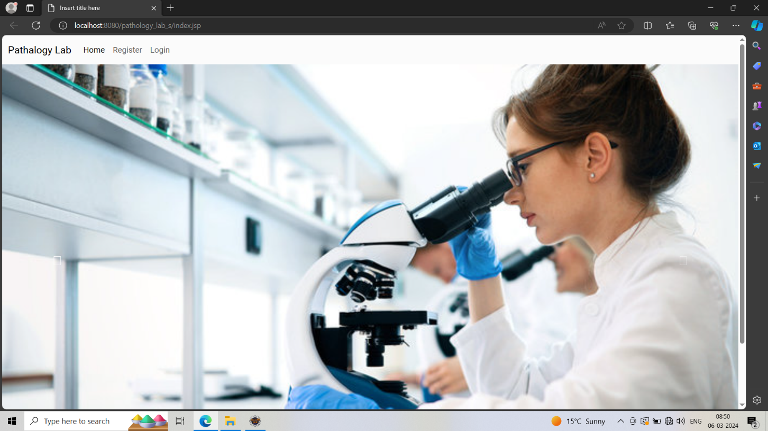

14

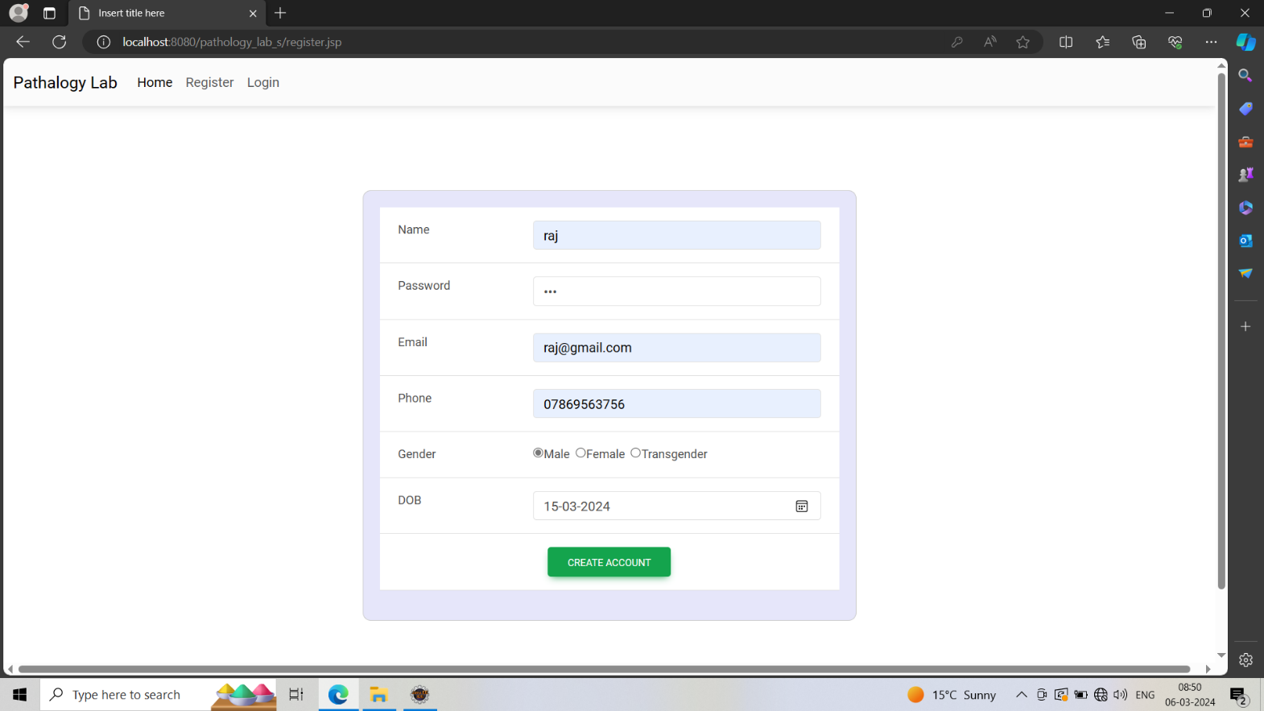

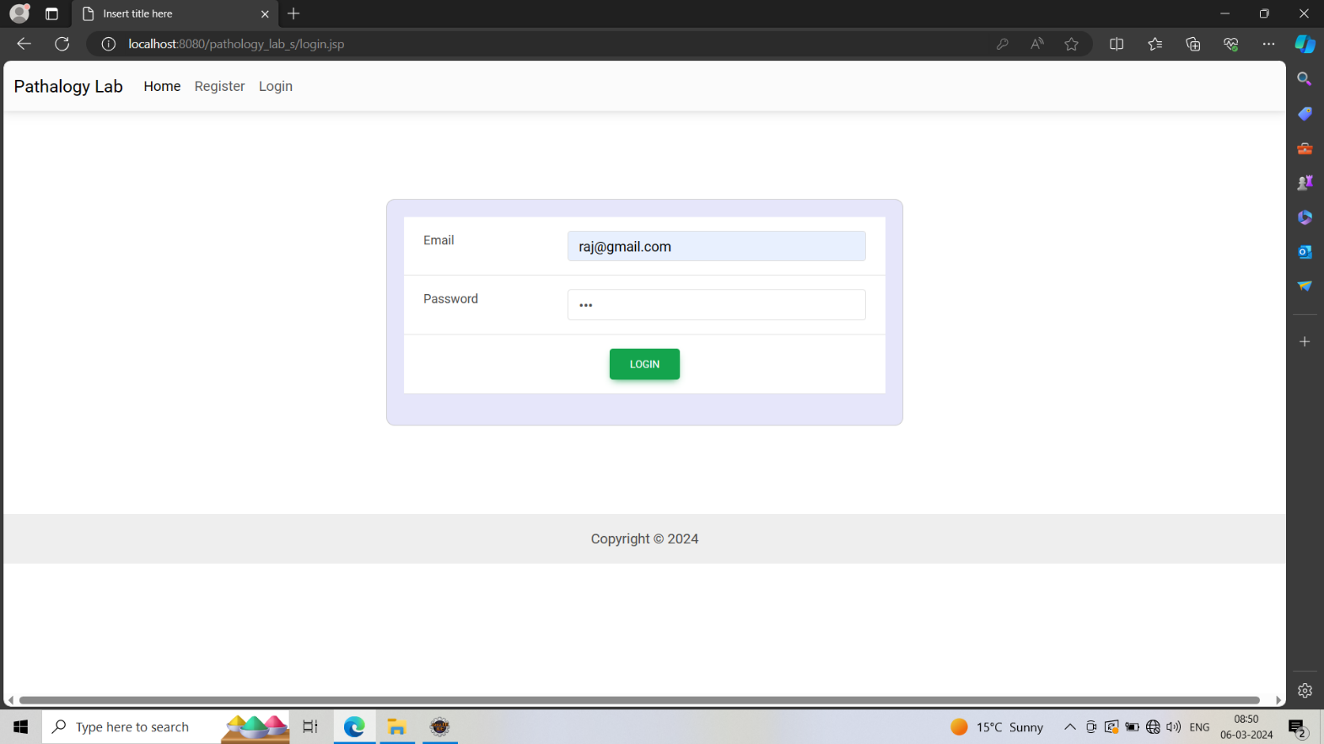

15

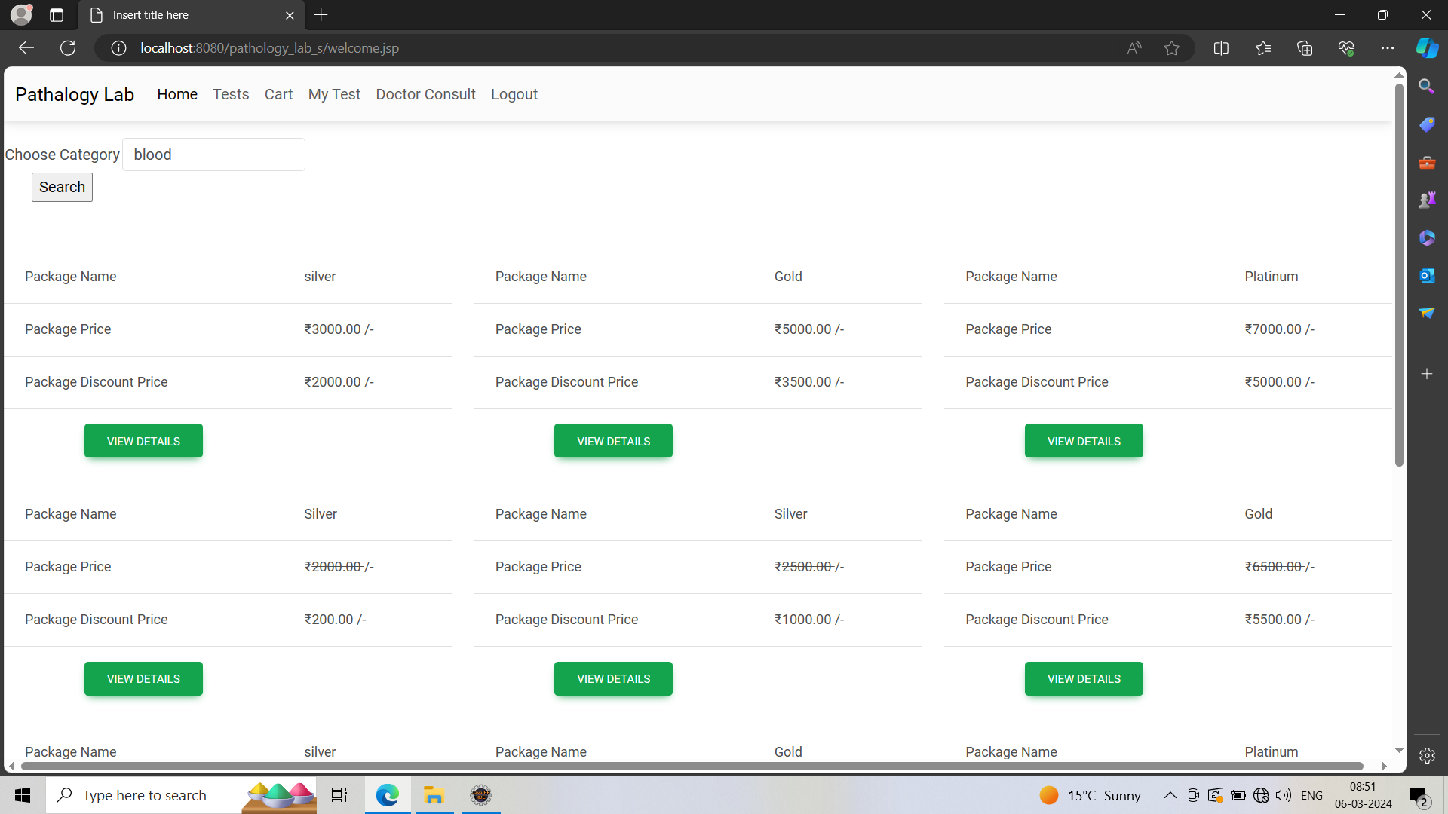

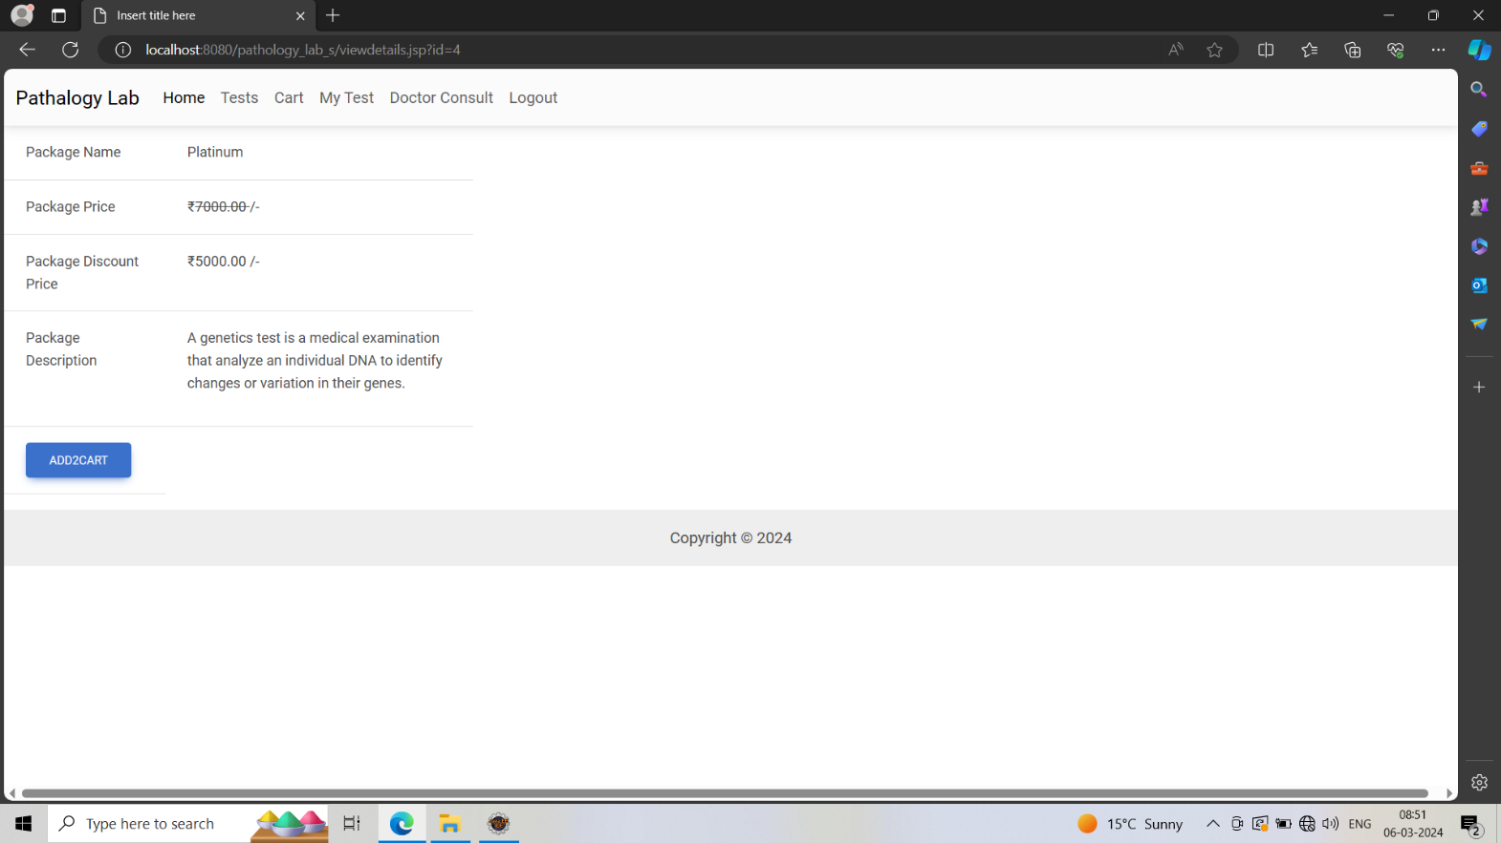

16

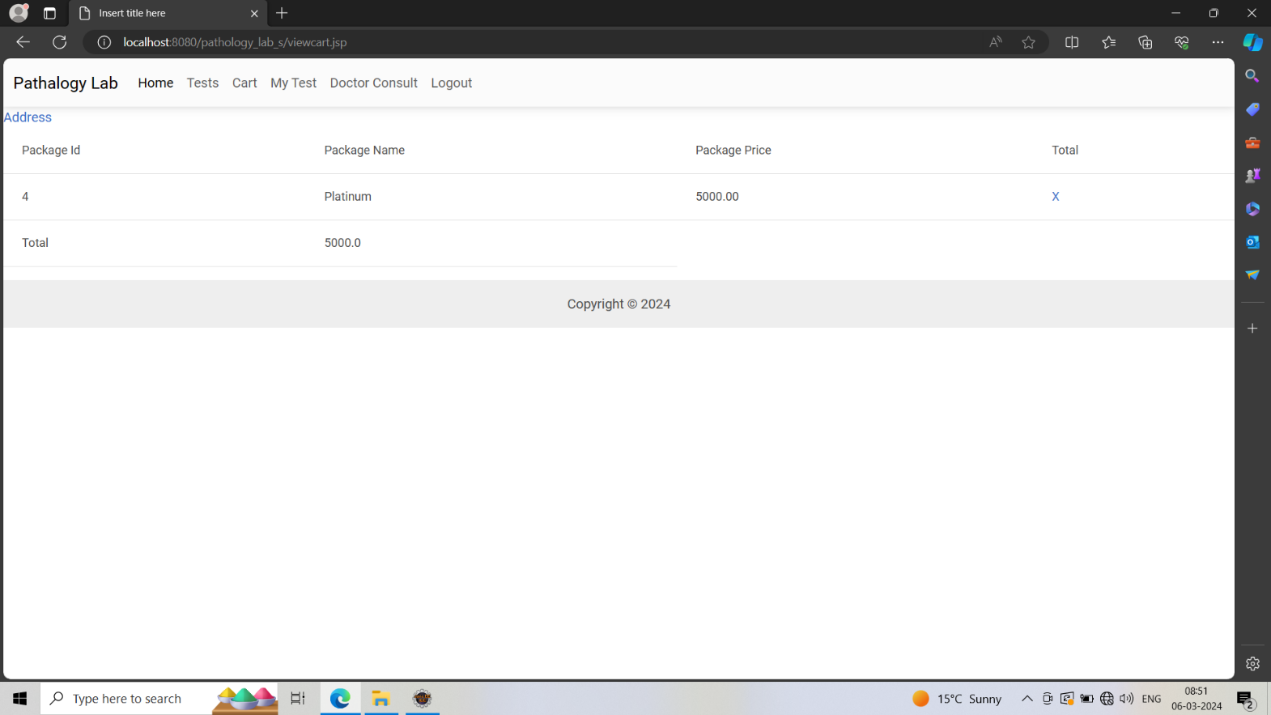

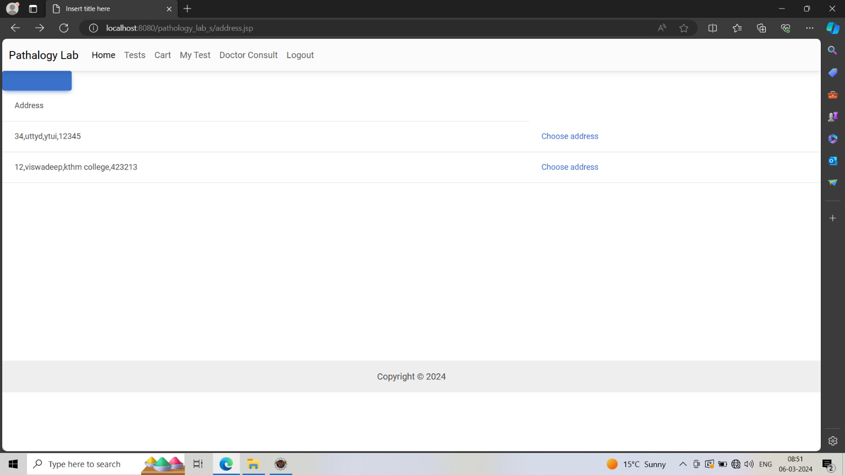

17

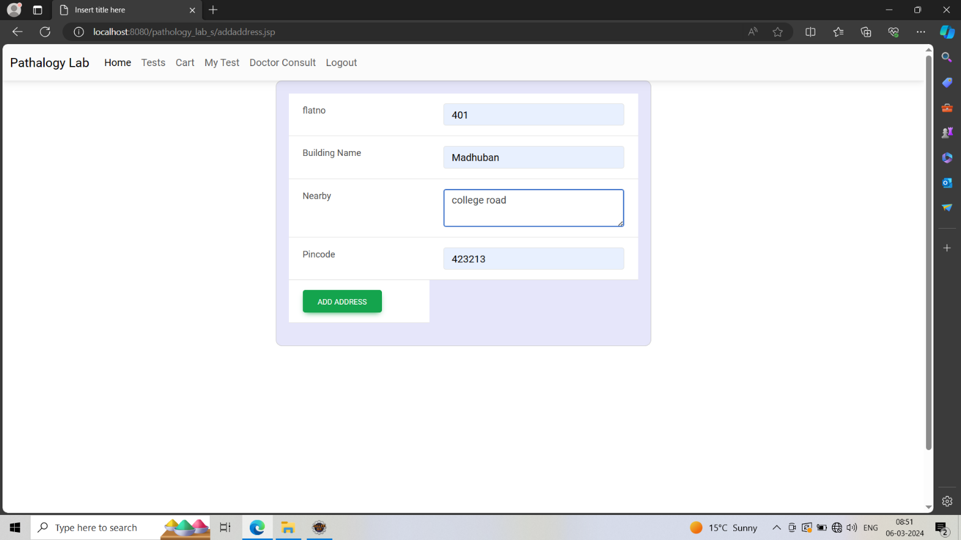

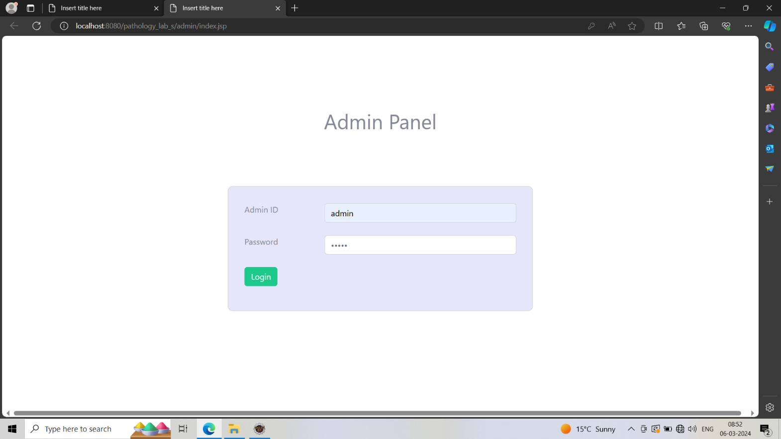

18

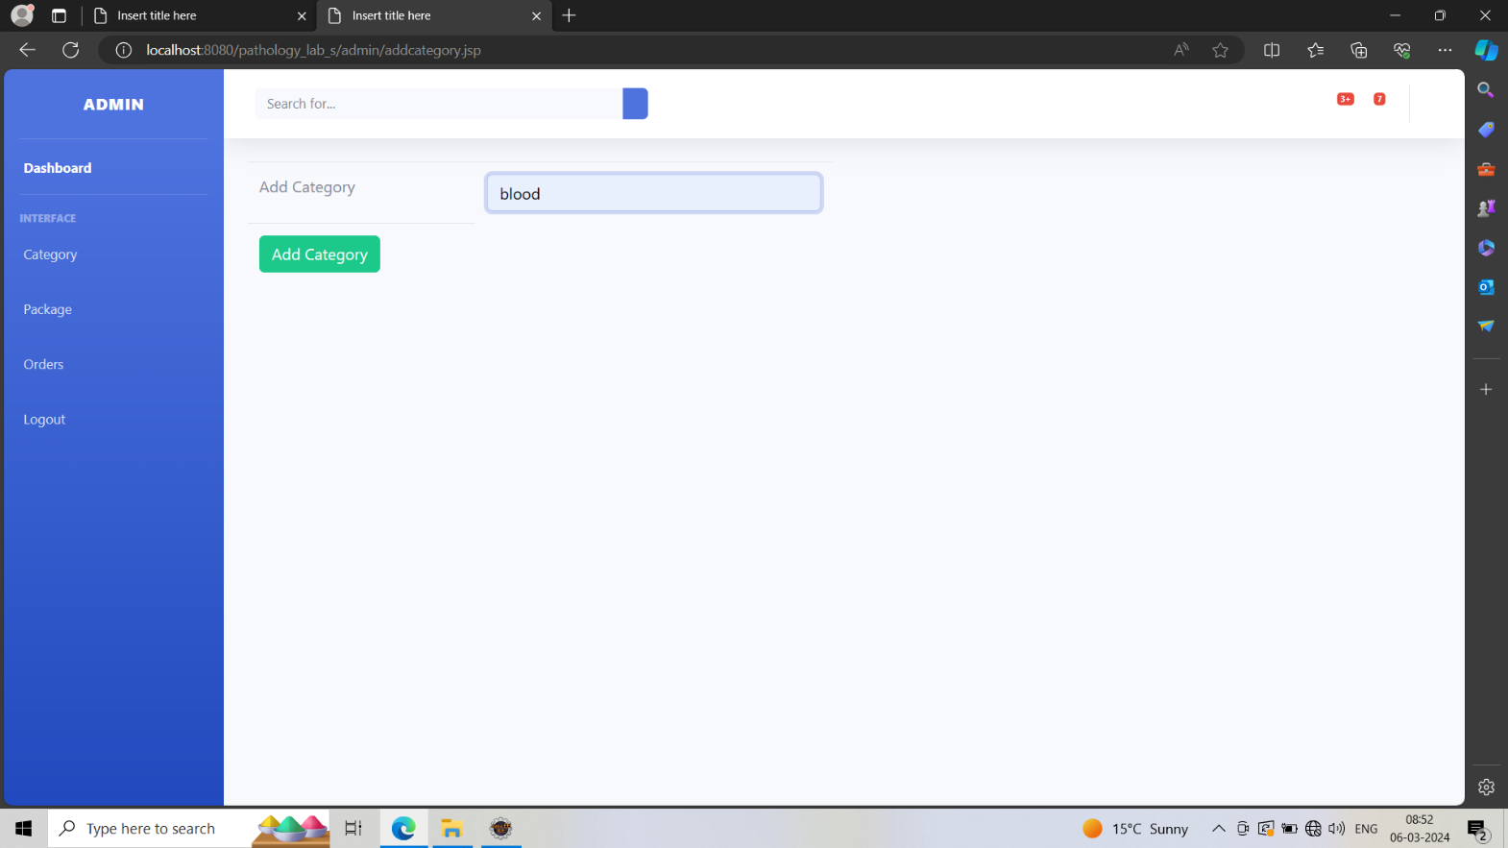

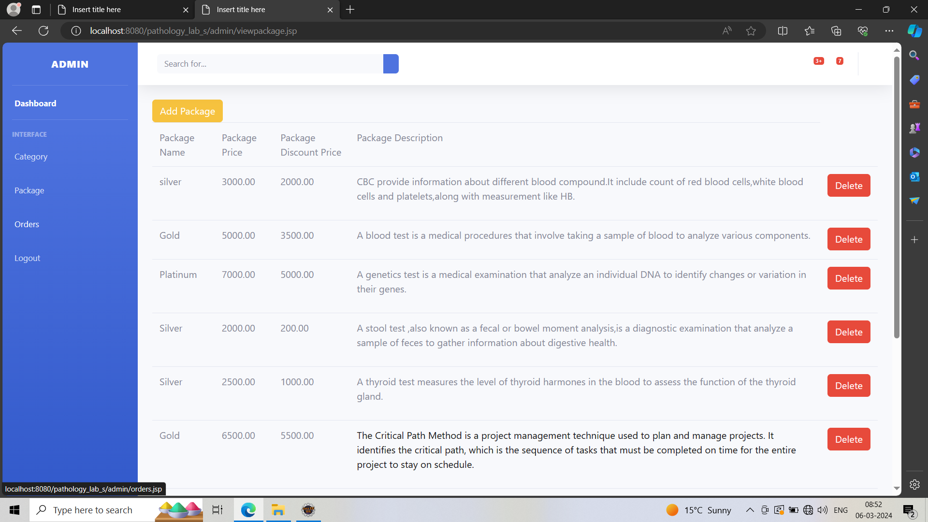

19

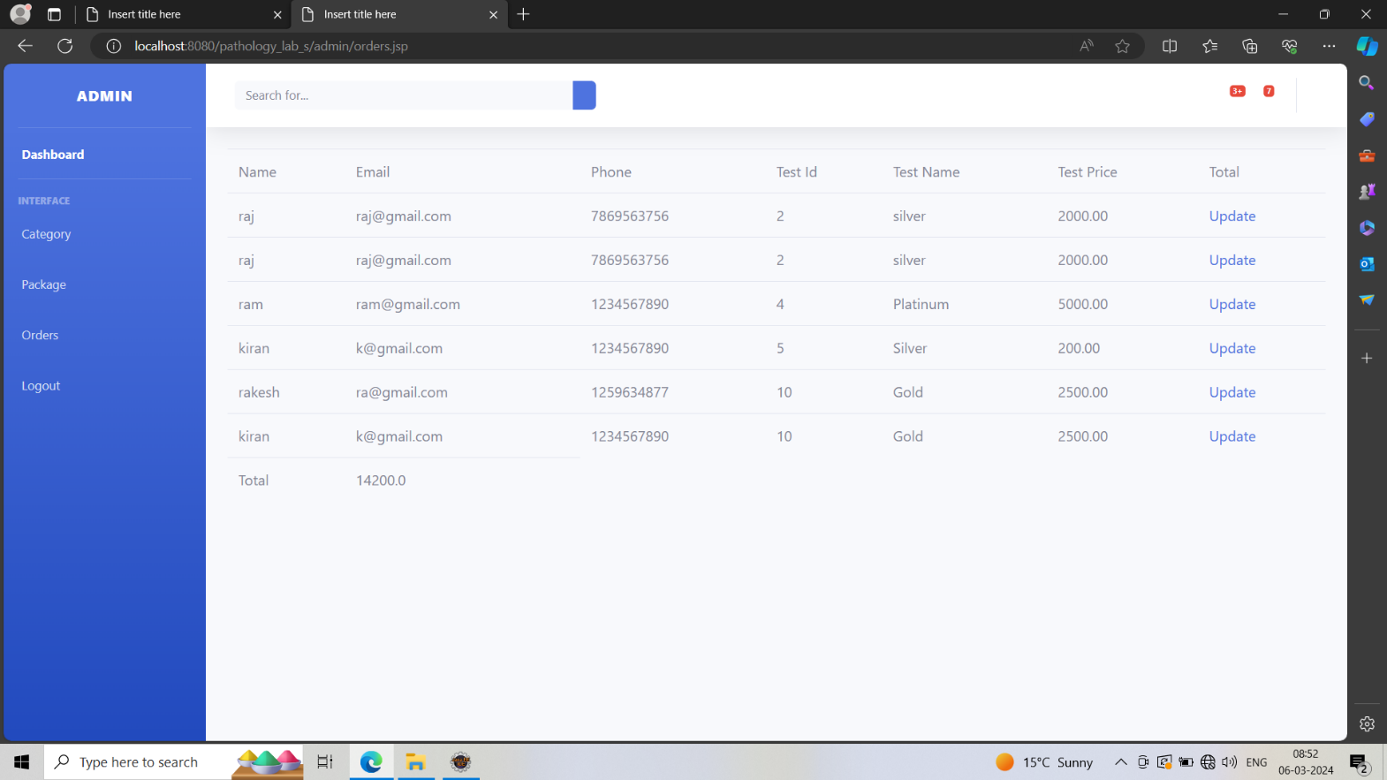

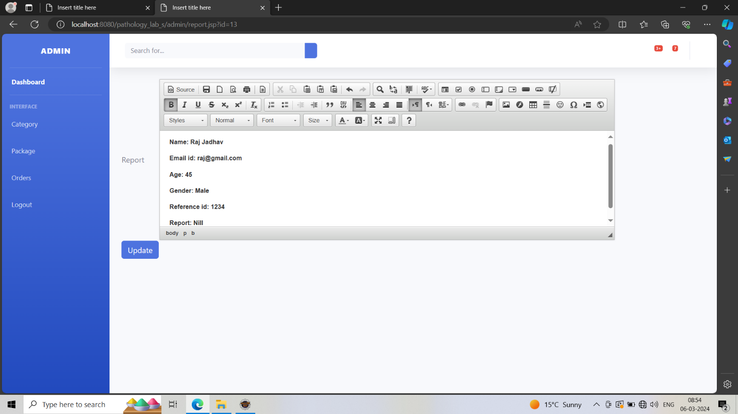

20

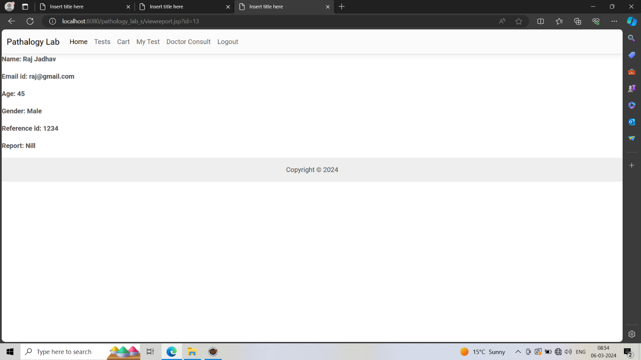

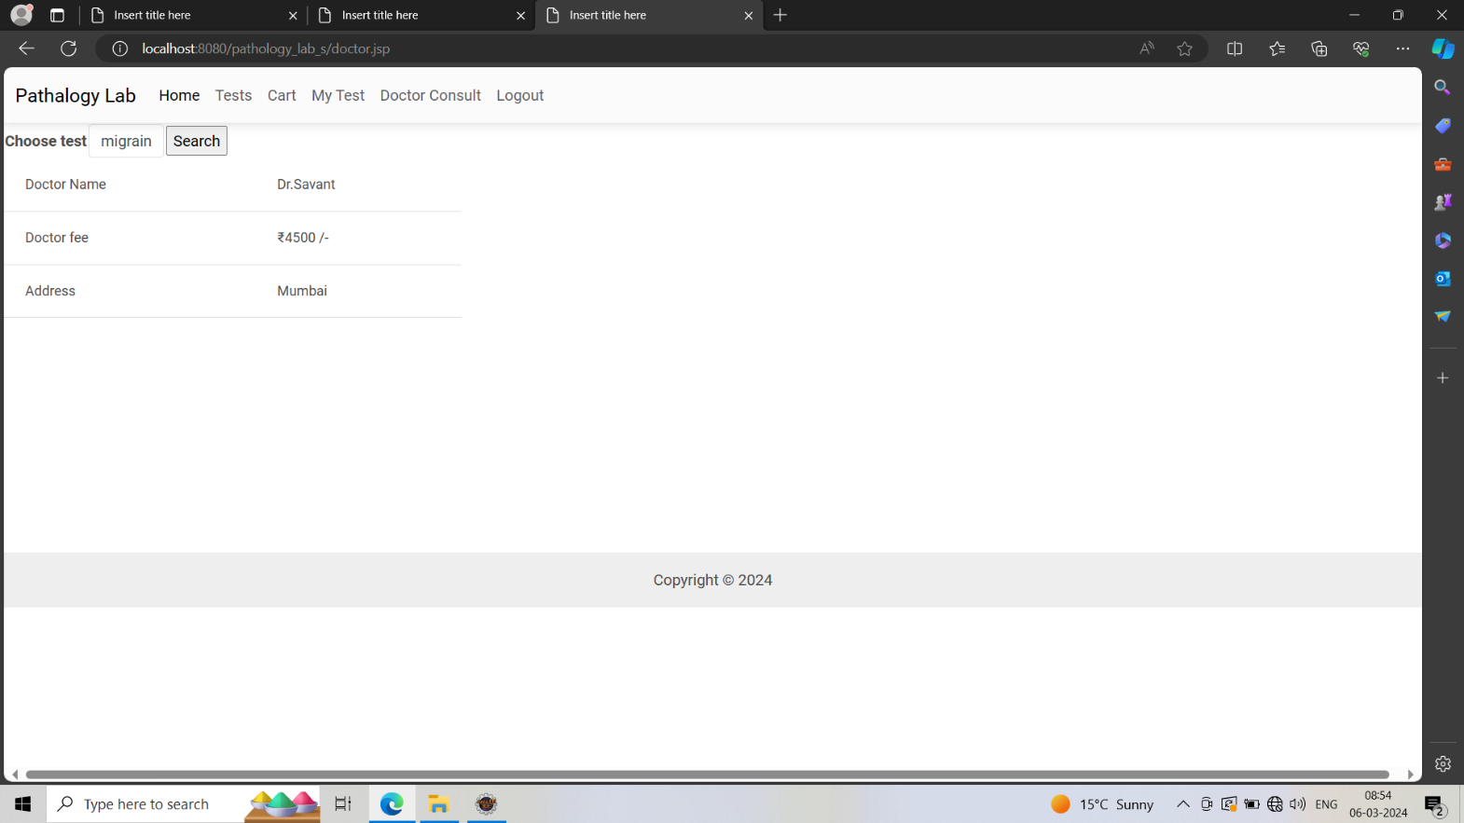

21

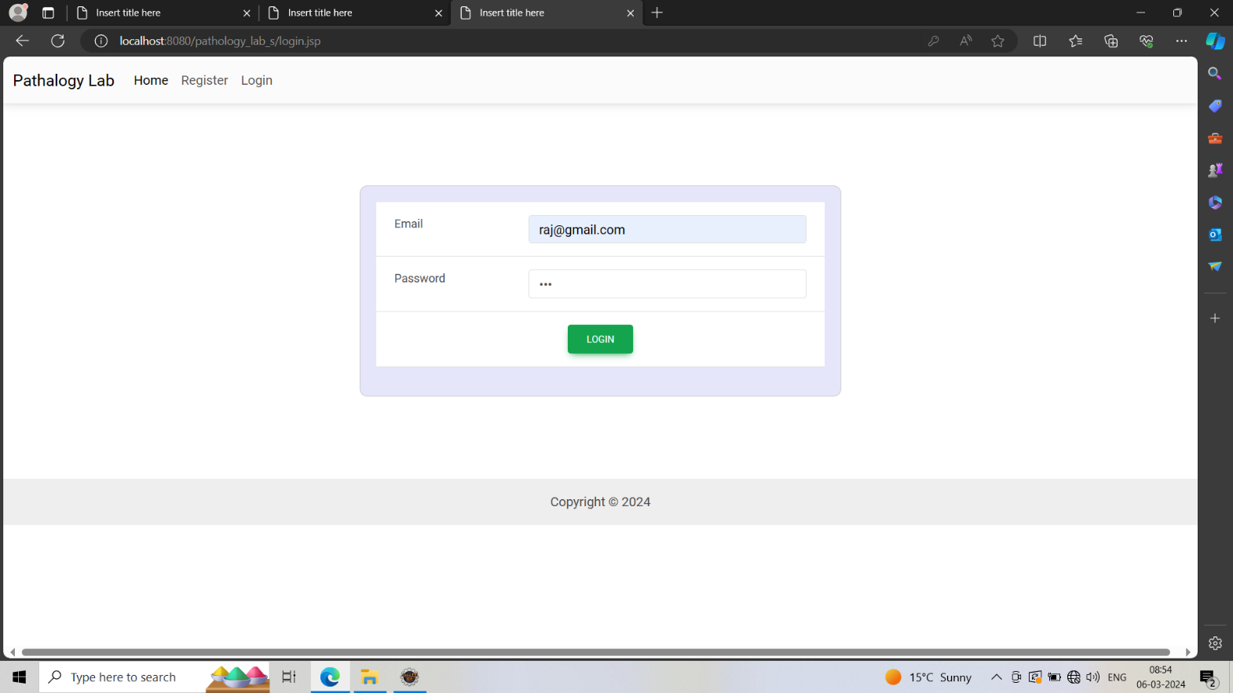

22

# CONCLUSION:

* Human errors are reduced.
* Data storage is done efficiently.
* Data retrieval is faster.
* Keeping a record of all entered was a very tedious job.
* Searching a particular entry was tedious because it involved searching all entries which required more time.
* The cost for maintenance is eliminated.
* Makes system user friendly.
* Our system provides two types of user administrator and local user which have a limited functionality. It improves the security.
* Only the users who have administrative rights are allowed to create or a modify users and unlock/lock users.

23

# LIMITATIONS

* It is fast, efficient and reliable.
* Avoids data redundancy and inconsistency.
* Very user friendly.
* Easy accessibility of data.
* Number of personal required is considerably less.
* Provides more security and integrity to data.

24

# BIBLIOGRAPHY



* 1. [http://www.google.com](http://www.google.com/)

## Learning PHP, MySQL & JavaScript-Robin Nixon

* 1. PHP for the Web-Larry Ullman
  2. [http://www.wikepedia.com](http://www.wikepedia.com/)

25